Man’s Obsession with Gold
To understand man’s obsession with gold, one first needs to know the science of why man was able to find gold in the first place. Gold is the least active metal. What does that mean? Gold is ranked last when the elements ranks their favorite elements to bond with.
LAST on their list of favorites!
Metal | Year of use
Gold | Gold flakes found in paleolithic caves dating 40,000 BCE, however man learned to regularly utilize gold 5,000BCE
Copper | Regularly used by 10,000 BCE
Silver | Coins made for trade as early as 600BCE with first known use 8,000-10,000 BCE
Platinum | Although very hard to mold and shape, it was found as early as 1,200-700 BCE
What other metals are unlikable? Platinum, silver, mercury, and copper. Are you beginning to see why early man was able to easily find these metals and utilize them in life? Here is a quick history of man and the use of metals.

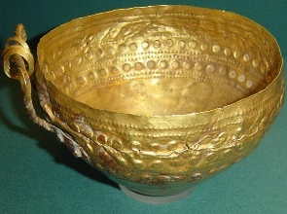
Being that other elements rank these metals as “unlikable”, they will be found in the soil quite easily. If one of these metal cations were actually bonded to another anion in a compound, they would quickly become REPLACED in a single replacement reaction by just about anything. Remember, they are the least favorite.
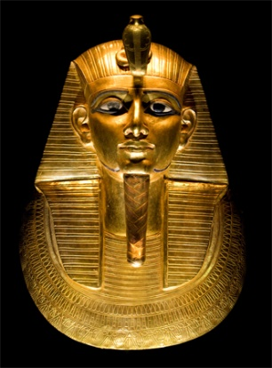
Being able to easily locate these metals in the soil, early man found many ways to use our precious metal

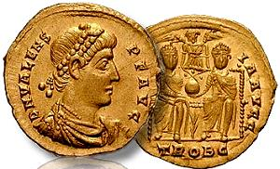
Today, we still cherish these metals and our society finds value in their possession.

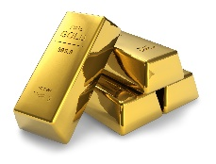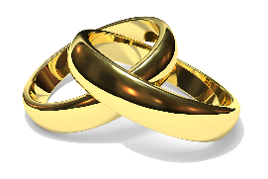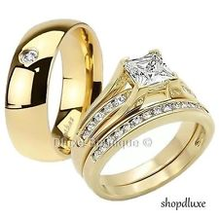
Other fun facts: Did you ever wonder why you turn green sometimes when you wear sterling silver jewelry? True silver is very malleable and would not hold shape well. Therefore, sterling silver has 88% silver and 12% of another easy to find metal.
Any ideas of what metal might turn green?
Copper!

