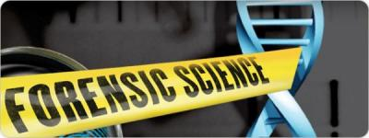
Forensic Science End of Year
Pro/Con
There were 8 units in forensics. I would like you to give me a pro and a con for each unit. There is no wrong way to do this. It could be factual concept that is either great for forensics or it could be factual that limits our advances. You could also give an opinion about either the concept itself or how you feel about learning that material.

THERE IS NO WRONG ANSWER.

Here are some ideas…
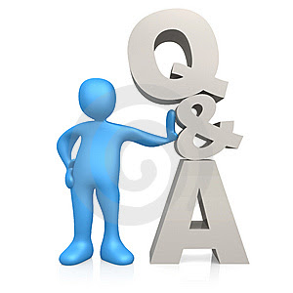
For example, DNA can have a pro that we are closing cold cases with familial DNA which could be someone’s con for logging each person’s DNA as an invasion of privacy.
You complete this on goformative.com by Tuesday, May 12, at 2pm which is the last day of class. You may choose to do it now and be done, or complete it by the end of class on Tuesday. Your decision. I am including some main points for the older units that we have done in case you have forgotten.

Once you are ready, head over to goformative.com and get started, remember that THERE ARE NO WRONG ANSWERS. I am just getting inside your head on how you feel about class.

1. Intro to forensic science
Main Ideas: Processing a crime scene, maintaining chain of custody, Law (Daubert and Frye), Evidence both direct evidence (testimony, eyewitness, hearsay) and indirect evidence (circumstantial evidence collected at scene)

2. TOD & PMI with Pathology, Entomology, and Anthropology
Main Ideas: Mortis terms, Cause of Death, Petechial hemorrhaging, Time of Death, Insects for TOD or possible location of death, Stages of Decomposition

3. Trace Evidence
Main Ideas: Hair, Fiber, Soil, Paint, Pollen (palynology)

4. Ballistics and Impressions
Main Ideas: Internal Ballistics (gun), External ballistics (trajectory), Terminal ballistics (wound or target), Tool marks, Shoe and other pattern, Glass Ballistics

5. Serology
Main Ideas: Blood typing, Blood spatter – passive (dropping with gravity), impact (low - punch, medium - crowbar high – gun), transfer (wipes, swipes and other transfer), projected (arterial gushing), Reconstruction of Crime via spatter

6. DNA
7. Document
8. Fingerprint

