Googling all the answer for molar mass is not successfully learning.

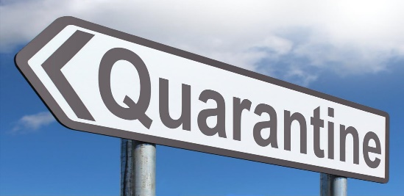
You will not be able to “google” answers once quarantine is over. Furthermore, when you google an answer try to ask the correct question. Nitrite and Nitrate are 2 totally different polyatomic ions giving them a different mass. Spelling is important when you try to cheat in chemistry. Otherwise, the google searched answer you give me will be wrong.

I gave you average atomic masses to use for the goformative expecting that you would use the given mass to calculate the molar mass.

Today, I am giving you pretend elements from my created Pandemic Periodic Table to use when calculating the problems on goformative.

So let’s try this again….
Helpful hints:
- Label for “mass” is grams or g
- Label for mass of a mole is still mass so just grams or g
- Label for “molar mass” is grams per mole or g/mol
- If your average atomic mass is rounded to the tenths, 0.1or one decimal place. Therefore, when you find the molar mass your final answer should still be to the tenths.

Sample Math:
1(2.0) = 2.0 3(1.4) = 4.2
3(14.1) = +42.3 2(2.4) =+4.8
44.3 9.0 (keep the zero to tenths)
Pandemic Periodic Table
1  Q  Quarantine  1.0 |  |  |  |  |  |  | 2  Co  Covid  2.1
3  Cr  Corona  4.7 | 4  V  Virus  6.9 | 5  N  Nineteen  8.7 | 6  B  Bored  10.0 | 7  S  Social  14.3 | 8  D  Distancing  17.2 | 9  Fm  FaceMask  19.9 | 10  W  WashHands  21.0

Find the molar mass of the following hypothetical Pandemic Molecules:
Virus FaceMaskide | VFm₂ | 1 V & 2 Fm | 6.9 + 2(19.9) =  39.8 | 46.7 g/mol
Corona Socialide  *like sulfide S⁻² | Cr₃S | 3 Cr & 1 S | 3(4.7) + 14.3  14.1 | 28.4 g/mol
Corona Socialite  *like sulfite SO₃⁻² | Cr₃SD₃ | 3 Cr & 1 S & 3 D | 3(4.7) + 14.3 + 3(17.2)  14.1 51.6 | 80.0 g/mol  *keep the zero at the end
Nineteen Quardistancide  *like hydroxide OH⁻¹ | N(DQ)₃ | 1 N & 3 D & 3 Q | 8.7 + 3(17.2) + 3(1.0)  51.6 3.0 | 63.3 g/mol

If you feel you need more practice, then use the additional practice that I have posted on my website with the answers.

If you feel that you will not get to the goformative by 2 pm, you must text me a with Remind101 text.

