Unit 8: Fingerprinting Notes
Case Study:
•Summarize the Will West vs. William West Case Here:

Fundamental Principles of Fingerprints:
A fingerprint is what type of characteristic? Class or Individual
Do prints change during an individual’s lifetime? Yes or No
Pattern class (loop) may be genetic, but ridge patterns are not. True or False
What is the difference between ridges and valleys? Ridges are black on lifted print or Valleys

Fingerprint Class Patterns:
–There are two types of arches:
•Examples:
•Plain Arch •Tented Arch
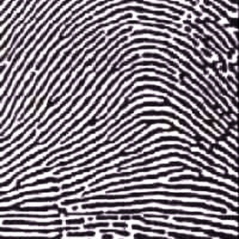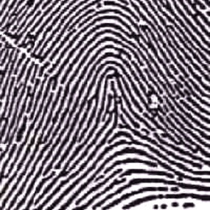

•What is the simplest type of fingerprint pattern?

Ridges enter on one side and cross to the other while going upward. There are no deltas or cores (centers).

•Loop Patterns:
-Loops must have one or more ridges entering and exiting form the same side.
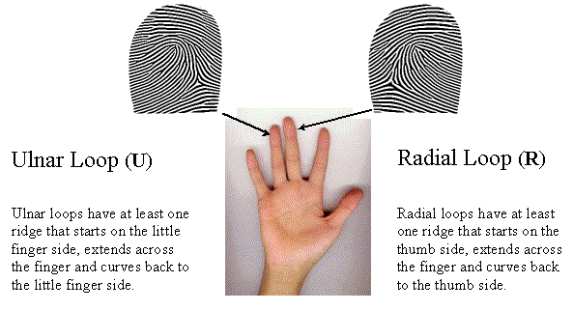
-Loops must have only one delta.
-There are two types of loops: ulnar and radial.

•Whorl Patterns:
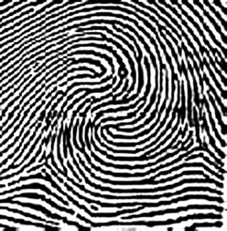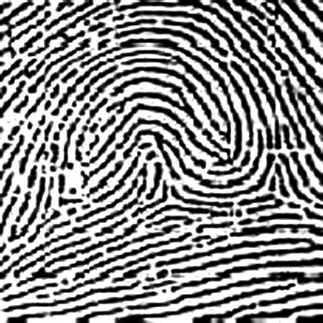
-Whorls are patterns that have at least:
-There are four types of whorls: Plain, Central Pocket, Double Loop, and
Accidental
Double Loop
A “S” shaped whorl with no true center whorl
Accidental
Does not fit the criteria to classify it as any of the previous three whorls.
Central Pocket
More asymmetrical. This is a whorl surrounded by a loop.
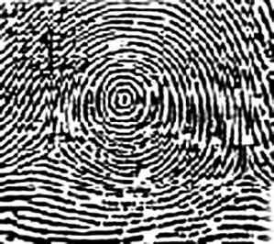-Plain
•More circular/symmetrical
•Draw a line from delta to delta, you will cut into the whorl pattern.

Ridge Characteristics:
•What is the definition of minutiae?

•Examples of minutiae for reference:

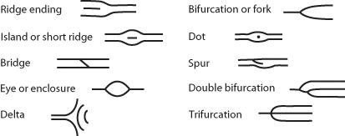
*I have seen only 1 trifurcation in my life of teaching with many kids and many prints…..usually it is a double bifurcation.

Label the Minutiae:

