What is a Mole
Background:
A unit was created to express the amount of a substance just like a dozen is 12 and a gross is 144. This unit, the mole, is defined as the number of atoms in exactly 12 g of carbon-12. To understand why, we must revisit atomic structure unit where the mass of protons and neutrons are both equal to 1 amu (atomic mass units).

Your turn….
1. A. What is the mass of Carbon-12? # protons _______ + # neutrons _______ = _______ amu or ________ g

- What is the mass of Carbon-13? # protons _______ + # neutrons _______ = _______ amu or ________ g

- What is the mass of Carbon-14? # protons _______ + # neutrons _______ = _______ amu or ________ g

2. Why are electrons NOT represented in determine the mass of the atom in the above question?

More Background:
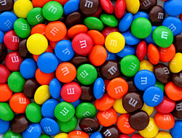
As you learned last class, the number of particles in a mole is called Avogadro’s constant or Avogadro’s Number. One mole represents 6.02 x 10²³ particles, which can be atoms, molecules or just about ANYTHING. You could have a mole of M&Ms for people quarantining in their homes. Do you think that is possible?
Think of the mole movie. If you are actually reading this, then you can send me a quick email to tell me if it is possible or not and why for a second coupon. Therefore, if you have exactly 12 g of carbon (atomic mass is 12) you have 1 mole or 6.02 x 10²³ individual atoms of C.
Do I just add the label “grams” to the ave atomic mass?
Yep! Measurement in chemistry is that easy! The MOLAR MASS is simply adding the label of grams to the average atomic mass.

Molar mass of sodium is 22.99g and hydrogen is 1.01g

Your Turn…
Find the molar mass of the following elements:
For example, the molar mass of Magnesium is 24.31g.

- Calcium ___________ C. Lithium ____________ E. Barium ___________

- Chlorine ___________ D. Oxygen ____________ F. Fluorine ___________

*If I had 24.31g of Mg then I would have exactly 6.02 X 10²³ atoms of magnesium or a mole!

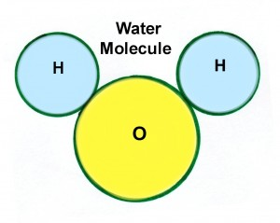
What about a compound made up of atoms bonded together?
Well if you know the mass of the parts, then just add them up!
H₂O is two hydrogen and one oxygen….
2(1.01g) + 1(16.00g) =
2.02g + 16.00g = 18.02g is a mole of water molecules.

Your Turn…

Find the molar mass of the following compounds:
For example, the molar mass of Magnesium Oxide, or MgO, would be 24.31 + 16.00 = 40.31g
& Sodium Oxide Na₂O is (2 X 22.99) + 16.00 = 61.98g

- CaCl₂ ___________ C. Li₂O ____________ E. BaF₂ ____________

- LiCl ___________ D. CaO ____________ F. Ba(ClO₃)₂ ___________

*If I had 40.31g of Mg0 then I would have exactly 6.02 X 10²³ molecules or a mole!

Atoms label is used for an element
Molecules label is used for compounds

Particles can mean BOTH!

Summary of the MOLE:
- There are 6.02 X 10²³ individual atoms of magnesium in 24.31g of Mg or 24.31 g/mole

- There are 6.02 X 10²³ individual atoms of sodium in 22.99 g of Na, or 22.99 g/mole

- There are 6.02 X 10²³ individual molecules of MgO in 40.31g of MgO, or 40.31 g/mole

- There are 6.02 X 10²³ individual molecules of Na₂O in 61.98 g of Na₂O or 61.98 g/mole

