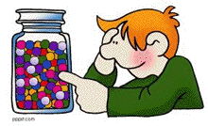
Understanding Accurate Measurement in Chemistry
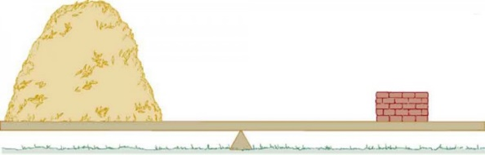
What weighs more a pound for feathers or a pound of bricks?
Okay, we have all heard that riddle. (Well, for those of you that haven’t…neither because they both weigh a pound!)
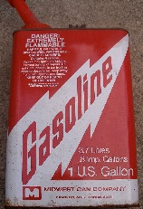
A pound of feathers and a pound of bricks both look very difficult. It is very easy to see that a feather and brick look quite different. It isn’t so easy with atoms and molecules.
A gallon of gasoline has a mass of 6.0 pounds, the same gallon of liquid hydrogen only has a mass of 0.567 pounds.
Regular Coca-Cola has a mass of 1.042g/ml while Diet Coke has a mass of only 0.997g/mL. Why? Sugar weighs more than artificial sweetener.
This is true for all phases of matter, even solids! Would you rather lift a meter block of cement or Styrofoam?
This makes for measurement difficult for a chemist. We know that the mass of our reactants must be equal to the mass of our products. However, mass of each type of material can be quite different. Lets look at the actual masses of producing water from hydrogen and oxygen.
H₂ + O₂ H₂O
There are 2 hydrogens and 2 oxygens attached because they are gasses and can easily make an octet with another atom of element. Remember that they are both DIATOMIC.
Then we balance…….
We need the same number of atoms on the reactant and product side. Law of Conservation of Mass requires us to make coefficients to hold the law true.
2H₂ + O₂ 2H₂O
What is being measured? | Hydrogen | Oxygen | Water
Liter at liquid state | 2.02g | 36.00g | 1000g
Volume comparison | 22.4 liters of gas | 22.4 liters of gas | About 3.7 teaspoons

We need to be able to measure the atom or molecule in order to ensure the measurement is accurate. Now, Mrs. H will explain how to measure material in the next lesson. However, today just trust me on this. It is actually pretty easy.
2H₂ + O₂ 2H₂O
2(2.02g of H₂) + 1(32.00g of O₂) = 2(18.02g of H₂O)
4.04g of H₂ + 32.00g of O₂ = 36.04g of H₂O

See...The LAW HOLD TRUE!!!! ALWAYS, ALWAYS, HOLDS TRUE!
So…It is time to learn about the method of measuring PARTICLES in chemistry which is more accurate.
Remember learning this in August? Particles are atoms and molecules.
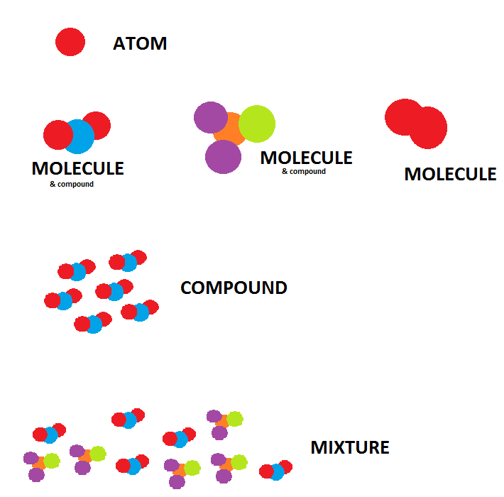

If you measure the particle rather than “bricks and feathers”, then you are truly measuring as a chemist. The mass or size of the material does not change when the number of particles is consistent.

However, we are unable to see particles in chemistry. Therefore, it only makes sense that in order to have enough particles to work with in the lab, the measured number is going to be really, really, really, really BIG!

The chemist’s measurement tool is known as THE MOLE.
And no…not the hairy animal that digs in the ground…..lol

This concept is quite possibly the most important concept you will learn in chemistry!

Time to watch YouTube video 1 and 2. Then go to goformative.com to answer a mole question that you research for the answer.

Mole video 1 https://www.youtube.com/watch?v=TEl4jeETVmg
Mole video 2 https://www.youtube.com/watch?v=PvT51M0ek5c

