Fingerprint Inquiry:

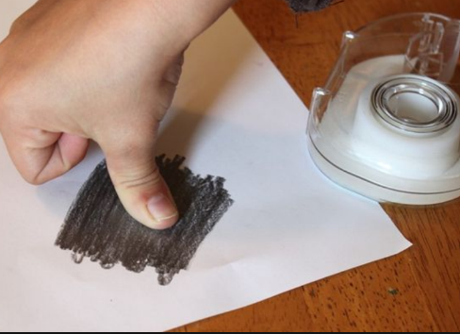
Activity Part 1: You may use a variety of methods to try and visualize your prints. Often using graphite powder from a pencil scratched on paper and then pulling it off your finger with tape is the best method. If you have one handy, you can use an ink pad instead of a pencil to make your print.

You may have a family member who may allow you to use clay, makeup, or even paint. If you can, place your print on a piece of paper that could include all 10 digits. (or a flat clay)

Please determine the percent for your fingerprint statistics.

Next, fill in the table below:
Fingerprint Classification: | Percent (ex.# of arches/10 x 100)
Arch
Loop
Whorl
- You will share your stats on goformative.com Reference:
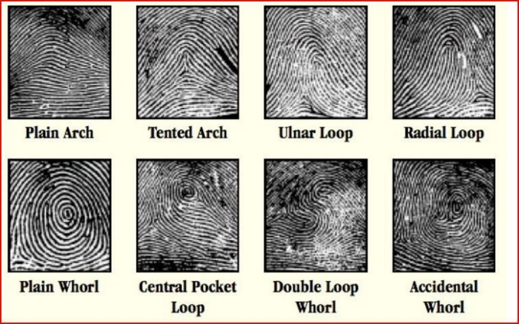
The general public has a fingerprint statistic of
60% loop (radial & ulnar loops)
35% whorls (plain, double loop, central pocket loop, & accidental whorls)
5% arches (plain & tented arches)

Mrs. H has ALL ULNAR LOOPS! I am pretty boring when it comes to prints.

Activity Part 2: Find prints around your house! I am seriously saddened that we are not in school for prints. We save that for last because it is the easiest and MOST FUN! Usually, during our fingerprint unit my former students would always come to class telling me that they can’t stop analyzing prints on everything. Those that worked retail would tell me that they would keep the glass counter by the register super clean and once the customer left, they would analyze their prints. Look through your house and try to locate prints. THEY ARE EVERYWHERE! If you have an old paintbrush or makeup brush you can try to use flour, graphite, blush, or any colored powder to try to dust. Once done, just grab tape and you can pull it up. I can see a few on my living room window right now as I am typing! Lol (along with a few dog nose smudges. Speaking about smudges...lipstick can show you lip print which is also unit to each individual. We just don’t use our lips when we commit a crime.)
Classes left….

4/30 Alternate prints with a quick goformative quiz.

5/5 Preparing to match a fingerprint minutia goformative quiz

5/7 Final Forensic Activity

5/12 Last day of class!!!!

