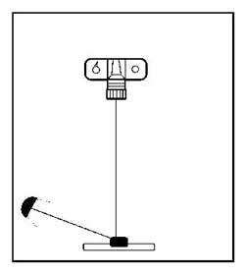
Alterations and Obliterations:

Introduction-
Often documents are changed after they are prepared. Common methods include: using a rubber eraser, scraping the ink off the paper, or using chemical methods to obliterate words. Examples of obliterations are chlorine or sodium hypochlorite (makes the ink colorless). Alterations, such as erasing or scraping remove the top layer of paper. A UV light can make the alterations easily visible because they will be darker than usual. Obliterations can be detected using UV, IR (infrared) light or photography. Indented impressions are left on the paper beneath the primary writing because of the pressure of the writing utensil. These impressions can sometimes be used to forge a signature, but often they also lead to the arrest of criminals.
Oblique lighting uses a light source at a low angle, usually to show detail by creating shadows in the subject surface. It is commonly used when photographing impressions, tool marks and certain types of fingerprints. This method will sometimes make the indented impression visible.

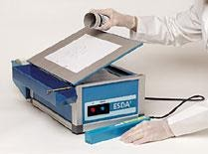
Indentations also increase a paper’s capacity to hold an electrostatic charge, so you can develop indentations with an ESDA (electrostatic detection apparatus). Basically, you pour toning powder from a copy machine over a charged sheet of plastic covering the paper in question. You must photograph the results because they are not permanent!

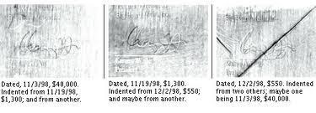

Questions to add to your running document:
Either add your answer with a complete thought or be sure to add the question.

- What is the difference between an alteration and an obliteration?
- Explain how oblique lighting is used to photograph impressions.
- What is ESDA and how is it used?

